**Chapter 1**

**ABSTARCT**

Student Information Management System (SIMS) provides a simple interface for maintenance of student information. It can be used by educational institutes or colleges to maintain the records of students easily. The creation and management of accurate, up-to-date information regarding a students’ academic career is critically important in the university as well as colleges. Student information system deals with all kind of student details, academic related reports, college details, course details, curriculum, batch details, placement details and other resource related details too. It tracks all the details of a student from the day one to the end of the course which can be used for all reporting purpose, tracking of attendance, progress in the course, completed semesters, years, coming semester year curriculum details, exam details, project or any other assignment details, final exam result and all these will be available through a secure, online interface embedded in the college’s website. It will also have faculty details, batch execution details, students’ details in all aspects, the various academic notifications to the staff and students updated by the college administration. It also facilitates us explore all the activities happening in the college.

Student Management System (SMS) provides a simple interface for maintenance of student information. It can be used by educational institutes or colleges to maintain the records of students easily. The creation and management of accurate, up-to-date information regarding a students’ academic career is critically important in the university as well as colleges.

It will also have faculty details, batch execution details, students’ details in all aspects, the various academic notifications to the staff and students updated by the college administration. It also facilitates us explore all the activities happening in the college, Different reports and Queries can be generated based on vast options related to students, batch, course, faculty, exams, semesters, certification and even for the entire college.

**Keywords: Student Management System, Database, HTML, SQL**

**Chapter 2**

**INTRODUCTION**

**2.1 Introduction**

The design and implementation of a comprehensive student information system and user interface is to replace the current paper records [1]. College Staff are able to directly access all aspects of a student’s academic progress through a secure, online interface embedded in the college’s website. The system utilizes user authentication, displaying only information necessary for an individual’s duties. Additionally, each sub-system has authentication allowing authorized users to create or update information in that subsystem. All data is thoroughly reviewed and validated on the server before actual record alteration occurs. In addition to a staff user interface, the system plans for student user interface, allowing users to access information and submit requests online thus reducing processing time. All data is stored securely on SQL servers managed by the college administrator and ensures highest possible level of security. The system features a complex logging system to track all users access and ensure conformity to data access guidelines and is expected to increase the efficiency of the college’s record management thereby decreasing the work hours needed to access and deliver student records to users.

Previously, the college relied heavily on paper records for this initiative. While paper records are a traditional way of managing student data there are several drawbacks to this method. First, to convey information to the students it should be displayed on the notice board and the student has to visit the notice board to check that information. It takes a very long time to convey the information to the student. Paper records are difficult to manage and track. The physical exertion required to retrieve, alter, and re-file the paper records are all non-value-added activities.

This system provides a simple interface for the maintenance of student information. It can be used by educational institutes or colleges to maintain the records of students easily. Achieving this objective is difficult using a manual system as the information is scattered, can be redundant and collecting relevant information may be very time consuming. All these problems are solved using online student information management system. The paper focuses on presenting information in an easy and intelligible manner which provides facilities like online registration and profile creation of student’s thus reducing paper work and automating the record generation process in an educational institution

**2.2 Purpose**

The purpose is to design a college website which contains up to data information of the college. That should improve efficiency of college record management.

**2.3 Objectives**

* Providing the online interface for students, faculty etc.
* Increasing the efficiency of college record management.
* Decrease time required to access and deliver student records.
* To make the system more secure.
* Decrease time spent on non-value-added tasks.

**Chapter 3**

**LITERATURE REVIEW**

In India there are many academic institutions. But very few institutions are modernized and use software to manage their day-to-day work. In a city like Bengaluru there are around 1000 schools, more than 300 pre-university colleges and degree colleges. Most of these academic institutions still relay on traditional way of management which mainly involves paper-work, much of human effort.

The students, who are admitted to those institutions which are dependent on traditional way of managing things, have to struggle a lot just to get a certificate or any other documents. Also, the administrations face difficulty in maintaining all the records, tracking the records and fetching the record of their interest in time. The administrations of those institutions also have to employ a number of employees just to maintain the records required to manage and support their daily work.

Some of the universities like PESIT and Christ University in Bengaluru have their own web application to address the previously mentioned issues.

The web application that is being used by these and many other institutions have the following features and functionalities such as, Login/Sign Up, Dashboard.

Any discussion of previous findings on the effectiveness of webbased homework management systems must first begin with a definition of the term. The web-based homework management system under consideration in this study is a system created by a major textbook publisher with thousands of users around the world. More broadly, web-based homework management system refers to a system that is accessible from any standard internet browser, that includes password authentication, transmission of assignments to students, collection of student answers, and automatic grading and recording (Bonham, Deardorff, & Beichner, 2003).

Even with the term carefully defined, the very question of learning effectiveness itself remains ambiguous. This study relied upon student performance on exams as a measure of learning because in this course the exams were the only summative assessment of learning. Two dominant themes emerge in the discussion of the effectiveness of homework management systems. Does the use of a web-based homework management systems increase student learning as reflected in improved exam scores? Is any increased student learning superficial in nature or does it include deeper understanding of the content?

Anthony [3],Ackoff [1], Koontz and O'Donnell [7], and McGuire [8] discuss about general management literature. This literature has ad-vacated basic principles of management, but they are far too wide to be of express use in collecting data for the review of an existing management system and they do not link the theory to the design of better management systems. However, the structure provided by these principles is necessary for the orderly development of our approach.

Glans, et al.. [6] and Couger [5] explains about systems analysis. These authors have tended to confer very detailed questions about systems operations. They often include checklists, paperwork flow analysis dealings, flowcharting, and other techniques which are used to analyze the clerical or operating subsystems of an organization. The approach tends to be ad hoc in nature and it presumes the type of improvements which are needed. Moreover, the systems analysis approach has notion the past concentrated sufficiently on the planning and control functions of management. Rather, it has been primarily concerned with improving operations. There is a need for the development of better methods for the review of management systems. In developing the review phase, the thrust is to provide an approach which is based on data collection and analysis and is systematic in nature. The next section provides a general description of the review phase structure which forms a basis for the development of specific data collection methodology.

Sanket Kale et.al 2017 implement a system which can manage project cognate all work consummated by utilized and Project coordinator or guide. Coordinator updates project cognate information, view work done by a student at which time and view progress chart of work done by student, progress chart is developed utilizing WBS (―Work Breakdown Structure‖).

“A Case Study of an Online Assignment Submission at UOMV. Ramnarain-Seetohul, J.Abdool Karim,A. Amir”- This paper explains that how the assignments given to the students can be managed online. This paper provides a platform for students as well as teachers for proper assessment regarding the assignment. It also shows that how this online submission can help in removing the traditional process of manually submitting the assignments and it is very tedious to maintain all of the assignments of the students. This system also shows the graph of the feedback given to that system that how friendly it proved by the students as well as the teachers [1].

“Project Communication in Functions, Process and Projectoriented Industrial Companies- Jana Samakova, Kristina Koltnerova, Rudolf Rybansky”- This article is focused on the project communication management. This article describes that how much the communication in project is essential. It also describes that the process-oriented and project-oriented companies have better project communication management during the project life cycle [2]. The article says that if there is lack of communication between the members in the group then it may affect the progress of the work. Hence this survey paper helped us to improve the communication by providing a collaborative platform for project guide as well as the students.

“Project management theory and the management of research projects”- This paper discusses about the research done on the previous projects and the interpersonal dynamics of a research team. This article gave us the idea about maintaining all of the previous year projects in one single page so that there will be no conflicts in choosing the project topics. The article also describes about the management of that research so that every information which is being gathered for the improvement of the project should be evaluated and updated frequently.

“Web Based Student Information Management System” - S.R. Bharamagoudar, Geeta R.B., S.G.Totad”- This article describes that how the maintenance of the record of the students information can be done easily at one place. Thus it gave us the idea about maintaining all of the project related tasks at one single page. Also it tells about maintaining the progress report of the students based on their work performance. The article also describes about facilitating and exploring all of the activities happening in the college. Thus it gave us idea about providing notification regarding the new tasks allotted so that tasks can be done before or at due date

“A Multi-Objective Approach for the Project Allocation Problem”- The article describes that the system performs allocation of the project as well as allows academics to rate the projects. Examiners to bid for projects they wish to examine, students to propose their own projects, students to submit project deliverables, supervisors to follow projects more closely and allows project coordinators to have a heuristic view of the whole system. The system captures the preferences of examiners as well as students and allocates projects to them in order tomaximize the number of students who gets their first choice in their preference list [4].

“An Evaluation of On-Line Assignment Submission, marking and Return”-The article describes about the online submission of assignments, marking andreturn. The articles also describe about the effectiveness of the system, timeliness as it saves a lot of time than that of the traditional process and convenience of the operation as their positive aspects. Thus this article gave us the idea of making the project tasks online for the better assessment of the project. This article also reports on a formal evaluation to assess student perceptions of this new development.

“Web-based assignment submission and Electronic Marking”- The article describes that the system is used by students and teachers as a replacement for the old manual system. It describes that the students find it convenient to use the system to submit assignment from home and later retrieve their marked assignments through the web rather than having to collect hard copies from the university [5]. It also describes that though traditional way is a good process of communication with the professor for the proper guidance but at often times it is not possible for the students to report to the professor and submit the assignment. Hence this system is used the automate the traditional process of submitting the assignments and get it evaluated by the professor and marked it return. Even the teachers can able to maintain the submitted assignments at one place so that it will be easy to evaluate about the grades to be allotted to the particular student. Hence from this survey we get the idea of making the record of all the students who have being allotted the projects so that the students will get the complete progress report at the end of theproject submission and for doing this manually will consume a lot of time. And also this will be helpful for the professors to maintain the record of all of the student at one single page.

**A. Toward a Student Information System for Sebha University**

This paper [1] basically focuses on providing a simple interface for the easy collation and maintenance of all manner of student information. The creation and management of accurate, up-to- date information regarding students’ academic careers is critical students and for the faculties and administration of Sebha University in Libya and for any other educational institution. A student information system deals with all kinds of data from enrollment to graduation, including program of study, attendance record, payment of fees and examination results to name but a few. All these data need to be made available through an onlineinterface.

**B. A Study of Student Information Management Software**

This paper [2] focuses on providing information to support the operation, management and decision-making functions of enterprises or organizations. In the face of huge amount of information, it is required to possess the student information management system to improve the efficiency of student management. Through this system, the standardized management, scientific statistics and fast query of student information can be realized, and thus the workload of management can be reduced. In this paper, a typical student information management system will be established to realize the systematization, standardization and automation of student information relationship.

**C. Web Based Student Information System**

This paper [3] focuses on simple interface for maintenance of student information. The creation and management of accurate, up-to- date information regarding a student’s academic career is critically important in the university as well as colleges. Student information system deals with all kind of student details, academic related reports, college details, course details, curriculum, batch details, placement details and other resource related details too. It tracks all the details of a student which can be used for all reporting purpose, tracking of attendance, progress in the course, completed semesters, years. Different reports and Queries can be generated based on vast options related to students, batch, course, faculty, exams, semesters, certification and even for the entire college.

**2.1 Student Management System based on .Net Three-layer Structure**

Student Management system has been implemented by (Yang Qingshan, 2010) using .Net Architecture for better standardization, information management, and three-layer B/S structure. This architecture improves the security and maintainability.

**2.2 Design and implementation of Student Management System**

Similarly simplified friendly interface student management system has been designed and implemented with the use of Visual Basic 6.0 and the SQL Server 2000. This design has a fully functional, flexible and convenient application which provides friendly interface to the users (Zhibing Liu, 2010).

**2.3 A Project Report on Student Management System**

Kapil Kaushik (2011) also built a student management system with features like online registration of students, maintenance of students records and searching student records. Their system was built using HTML, JavaScript implementing PHP, MySQL (as back end). They also used Apache HTTP server and Dreamweaver (Kapil Kaushik, 2011)

**2.4 Web Based Student Management System (SIMS)**

S.R.Bharamagoudar, Geeta R.B and S.G.Totad also have built SIMS for maintenance of student information system solving the traditional way of managing the student records. The system was built using html, PHP and MySQL database.

**2.5 Student Management System for Sebha University, Libya**

They have devised a simple interface for the easy collation and maintenance of all manner of student information. They built a student database which had to be integrated with the web based system. And their student data system was used to collect and correct all student data at Sebha University (Almahdi Alshareef, 2015).

**2.6 Student Management System**

Dechen Wangmo (2015) et al. designed and built system software with features like course management, student semester registration, student bio data, disciplinary records and study information like course etc. Their system uses PHP framework named Laravel, html, java script, MySQL and Apache. Our group reworked on the system developed by this group. Evaluated by the users and finally deployed in the college starting winter semester 2016

**Chapter 4**

**SYSTEM REQUIREMENTS SPECIFICATION**

The requirements gathering process is intensified and focused specifically on software. To understand the nature of the program(s) to be built, the software engineer ("analyst") must understand the information domain for the software, as well as required function, behaviour, performance, and interface. Requirements for both the system and the software are documented and reviewed with the customer.

**3.1 Hardware Requirement**

The hardware requirements may serve as the basis for a contract for the implementation of the system and should therefore be a complete and consistent specification of the whole system. They are used by software engineers as the starting point for the system design. It shows what the system does and not how it should be implemented.

**• Processor:** I3 Processor

**• RAM:** 4GB Ram, 500GB HDD

**• Operating System:** LINUX/WINDOWS 10

**3.2 Software Requirement**

The software requirements document is the specification of the system. It should include both a definition and a specification of requirements. It is a set of what the system should do rather than how it should do it. The software requirements provide a basis for creating the software requirements specification. It is useful in estimating cost, planning team activities.

**• Front End:** JavaScript, HTML5, CSS3

**• Back End:** Java, Servlets, JSP, JDBC

**• Database:** SQL Database

**• IDE:** Eclipse, MySQL Workbench

**Chapter 5**

**SYSTEM DESIGN**

**5.1 Architecture**

The architecture proposed is based on 3-tier system. A front-end display allows the users (student, teachers, administration) to create a profile. The information is stored in a database in the server and retrieved whenever it’s required using our application

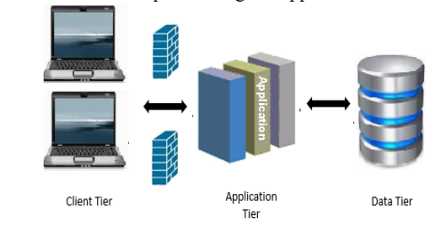

Fig.1 System Overview

The system is web based three-tier architecture developed keeping in mind that choice of users, the development time, flexibility and maintenance of the application.

These three tiers can also be referred to as logical layers where each layer performs a specific function and forms the reusable section of the code. These layers interact with each other layers in order to perform certain tasks. The presentation layer 11 which is also called as application layer provides various forms web forms, user controls, master pages etc., The presentation tier of the current application provide this functionality for the programmers to design the website. It has got HTML web forms, web controls, master pages, etc., for the above said purpose. In addition to this programmer also use this layer to get or set the data back and forth.

The Java has the support for all the master pages which has all the controls mentioned above and the user can make use of them for designing web pages and only the content tab will be loaded for different pages. Hence, I chose Eclipse IDE to design and code the JSP pages to make the website more interactive and also attractive. I made use of this feature in order to make the website pages look uniform and pretty as it has got common controls on the web pages making it easier for the programmer to design. This is the layer where the user interacts with the application part. The user provides input through this layer. From this layer further processing takes place by supplying the information to the layer below it which is the business layer or the middle layer.

The business layer which is also called as middle layer is responsible for sharing and controlling the business logic of the application. Programmers write the functions in this layer for getting data from the application layer or the presentation layer and passes through the data access layer. This contains several java classes and this can be noticed from the figure shown above. In addition to the above said functionalities, this tier is also responsible for increasing the code transparency and also for altering the database. The classes of this application viz., course, pos, user, login info, thesis advisor, student, faculty, is contained in this layer only. The business layer can be more clearly understood by the use case and class diagrams of the application which are shown below.

The application student management system uses MySQL Database and its database. This MySQL Database makes the search effective and convenient whenever the user (student or the faculty member) requests for the POS. The database schema for this application which comprises of five tables viz., student, login detail, courses, student courses and thesis student courses. From the figure all the fields and keys of the tables can be noticed

So because of all the above said functionalities of the three tier architecture, I felt it matches with all my requirements of the project and hence I have decided to go with three tier architecture for my current application.

**5.2 Data Flow Diagram**

Based on end user necessities as well as the thorough investigation on current system we have suggested a system that satisfies user requirements. Initially admin will be going to login to the system. Once he successfully logged in, he will be able to do add new student and faculty in system. to upload student details and faculty details. Admin may be head of the College. And he will give access to faculties and students.

Admin have the privileges to view/edit the details of both students and faculties. Also, he can send the circular or the notice to all faculties and students. Also, he can see the reports of the students’ and faculties. Faculty will be going to log in to the system. He can store the student attendance and internal assessment marks also he can view the same. And average of internal assessments calculated automatically. The faculty can generate report based on the student records like attendance and internal assessments.

Next mode of login is student log in. Students have to visit to the portal and need to provide the respective details, after that student will be registered. Admin will distribute the passwords to the faculties and student. Once they receive the password from the admin, they are able to login to the application and monitor the statistics. Once they receive the credentials, they are able to access the application. And also, to monitor the statistics like they can generate their own report of internal assessments and attendance and they can view their performance.

There are three types of users are created based on the access criteria. They are Admin, Faculty and Student/Guardian. Admin users are responsible for storing student data and faculty details, scheduling time table for faculties. Admin users can create, replace, update, delete (CRUD) the student and faculty details. Admin users can also generate all types of reports which are available in the application. Admin users will have all the privileges and access to the application. Admin user is a root user; he is having complete control over the application. Faculty users are responsible for maintaining the attendance of the students, internal assessments marks, generating time tables. Faculty users can generate report based on the student progress like internal assessment, attendance. Student/Guardian users are responsible for viewing their own page; they can check their academic progress, and attendance.

If logged in user is an admin user then he is the only person to manipulate all the necessary details regarding students and faculties.

**5.2.1 Zero Level Data Flow Diagram:**

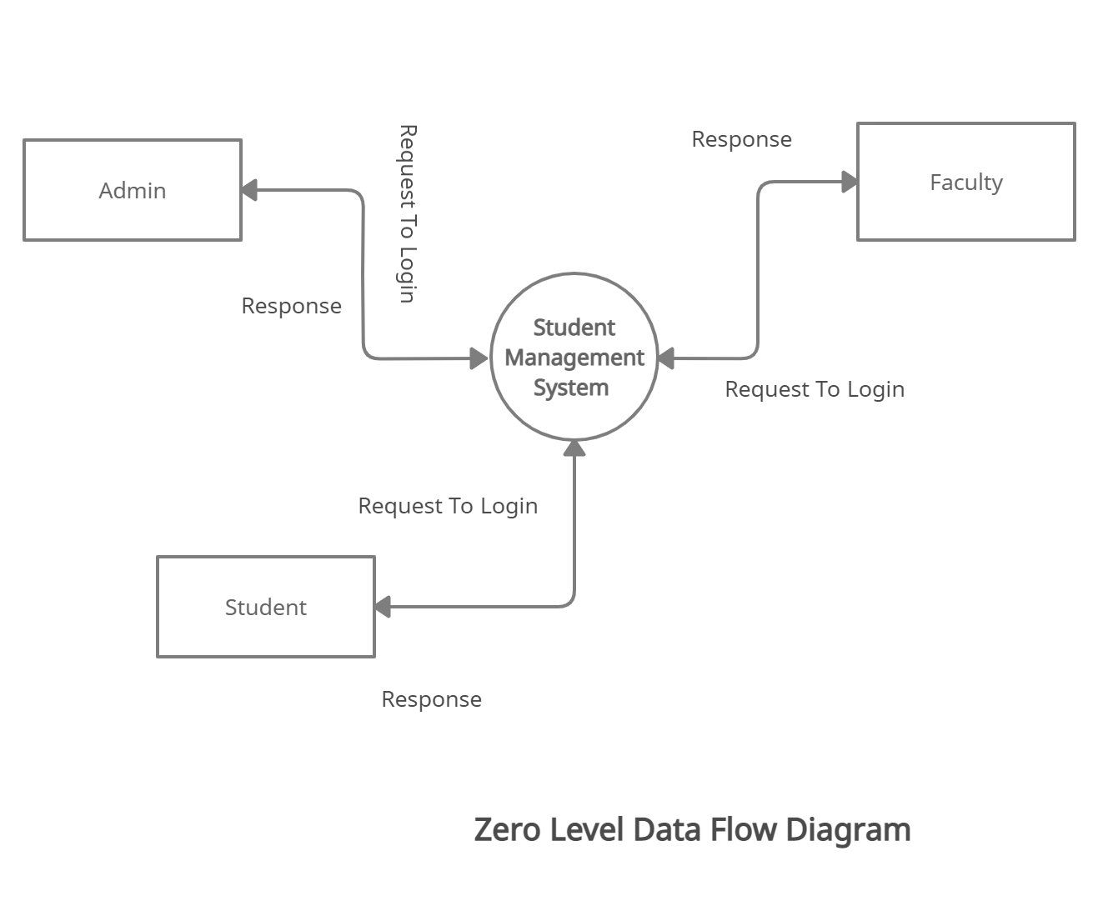

**5.2.2. 1st level Data flow Diagram:**

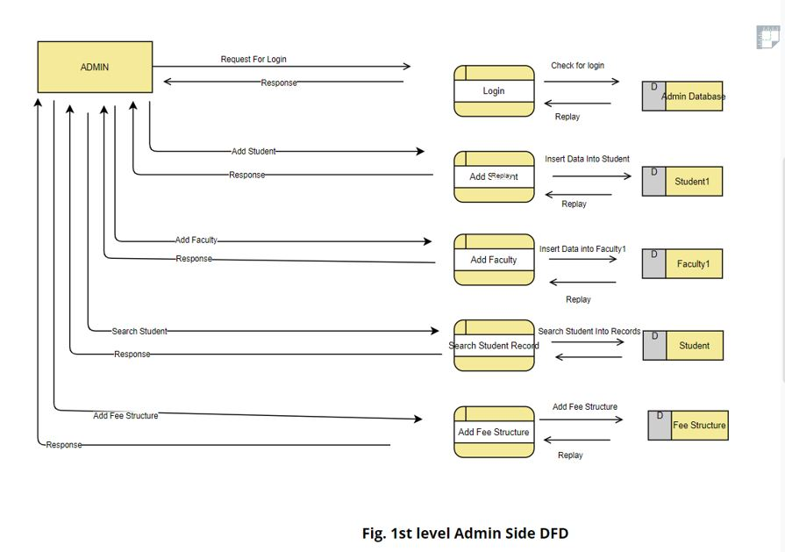

**5.2.3 2nd Level Data Flow Diagram**

**Admin:**

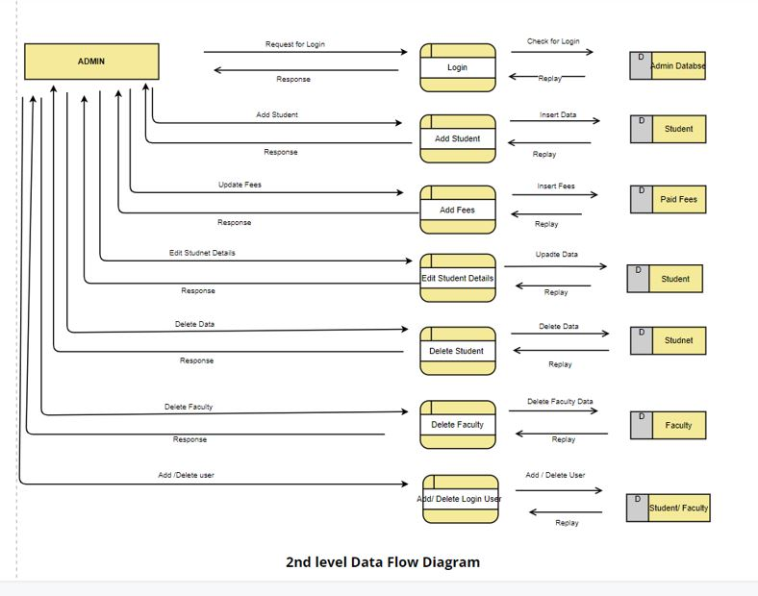

**Faculty :**

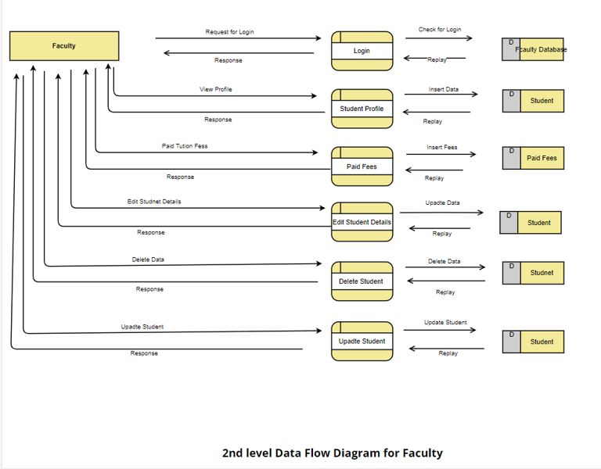

**Student :**

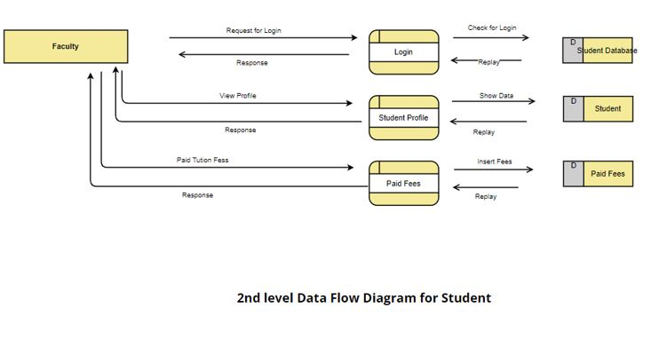

**5.3 Structural Design of Student Management System**

The structural design of the student management system. Users will login to the student management system. If the logged in user is an admin user, he will be able to register the students and faculties in the system, admin can only have the complete privileges on the system. He will be sending circular to the students as well as faculties regarding the upcoming events that will appear in the college.

When faculty user login to the system, his work is to manipulate the attendance and internal assessment marks as well as he is going to send circular to his students regarding his subject notifications like class test etc. Also, faculty will be able to generate the report of his students based on their progress in his class. When student user login to the system he can visit only to his pages and he will be able to check his academic progress as well as attendance. Also, he will generate report of his performance in internal assessments and in attendance. All these information is stored in the database

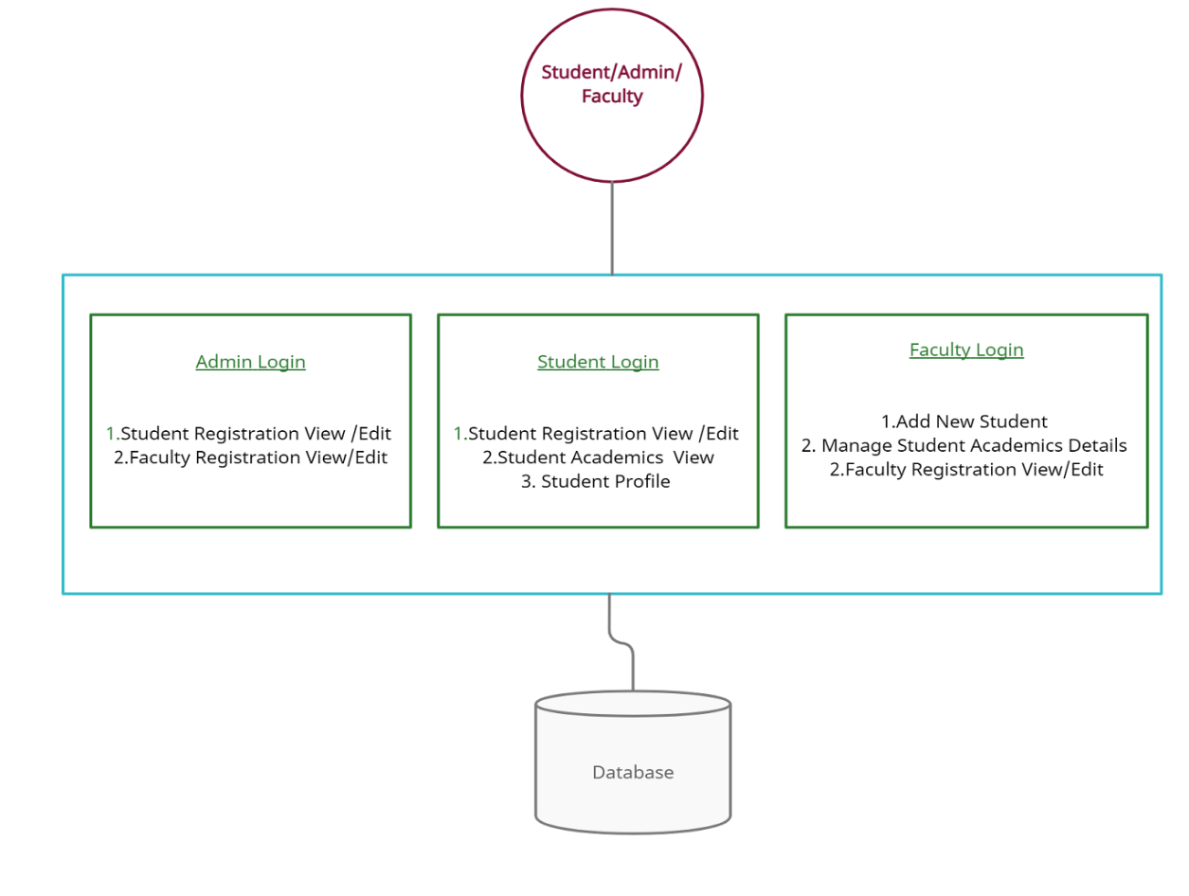

Fig. 4 Structural Design of Student Management System

**5.4 Design Overview**

The design of the student information management system includes the design of the home page which provides the way for all the students, staff and other user to access the system. Every user of the system has a unique username and password. The home page mainly contains a login form through which a new user can register, or an existing user can login to the system by entering the username and password.

1. **Student :**

The student is of center focus, because in every college student plays the very important role. Student can access the information of the college, course details, subject details, faculty details, training and placement cell information and exam section information wherein the course details include information regarding branch of studying, the academic calendar of the college, year wise subject offered by the branch, the subject details include the syllabus of the subjects, information regarding the staff handling the subjects, the subjects he presently registered for the semester he is presently studying, attendance and internal marks of the subjects, he can also ask any queries to the staff regarding the subjects. The placement details include the information about the companies, the eligibility criteria for attending recruitment of the companies, the process of recruitment, the date and time of the recruitment. The placement cell updates the students information who got selected for a company. The exam section details include the internals and external time tables, the room allocation for the exams, it also contains the semester end results.

1. **Faculty :**

Each teacher has one file that enables them to keep their schedules, students, and classroom information all in one place. That single database file allows administrators to have up-to-date information about the teachers and their classes at any time. It is faster for teachers to fill out classroom reports and forms using the interactive teacher database because all of the basic information including the teacher’s name and classroom details are automatically placed in the form.Teachers simply fill in the details and click OK. Reports and forms are automatically saved to the teacher’s file. They can also view the student details for better understanding the student performance and improving the efficiency of the student. The staff also gets the updates from the college regarding any events occur in the college. They can also get the notifications from the placement cell and exam section.

1. **Administrator:**

The administrator is responsible for entering the new student, promoting the student from one class to another, from one semester to another and from one year to another. Managing the student accounts like any changes regarding to the name, address etc. The administrator also manages the faulty accounts like entering a new faculty, assigning the faculty to the subjects. The administrator also updates the college related information like calendar of events, information regarding any other events that occur in the college. The administrator will check the all the updates i.e. student updates, faculty updates, exam updates etc. The administrator has the highest level of power in the student information system.

**5.5 Use Case**

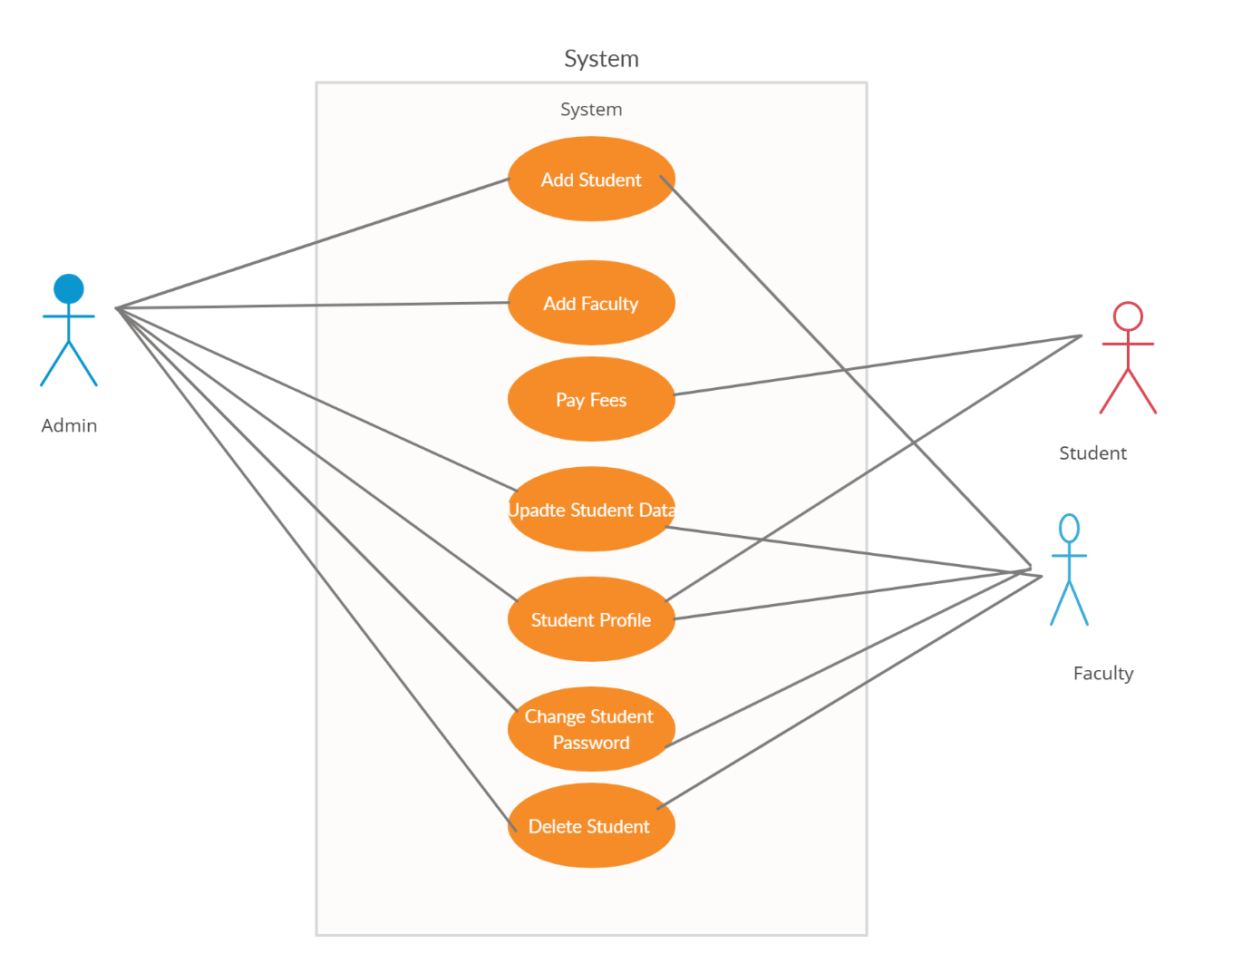

Fig. Use Case Diagram

**5.6 ER Diagram :**

E-R (Entity-Relationship) Diagram is used to represents the relationship between entities in a table. ER diagrams represent the logical structure of databases. ER Diagram represent relationship between two database tables.

E-R diagram means Entity Relationship diagram. Entity is a object of system, generally we refer entity as database table, the e-r diagram represent the relationship between each table of database. E-R diagram represent entity with attributes, attributes is a property of entity. If we assume entity is a database table then all the columns of table are treated as attributes.

**Entity:** Entities are represented by **rectangle**. All table of database are treated as entity.

**Attributes:** Attributes are represented by **ellipses**. Attributes are properties of entities.

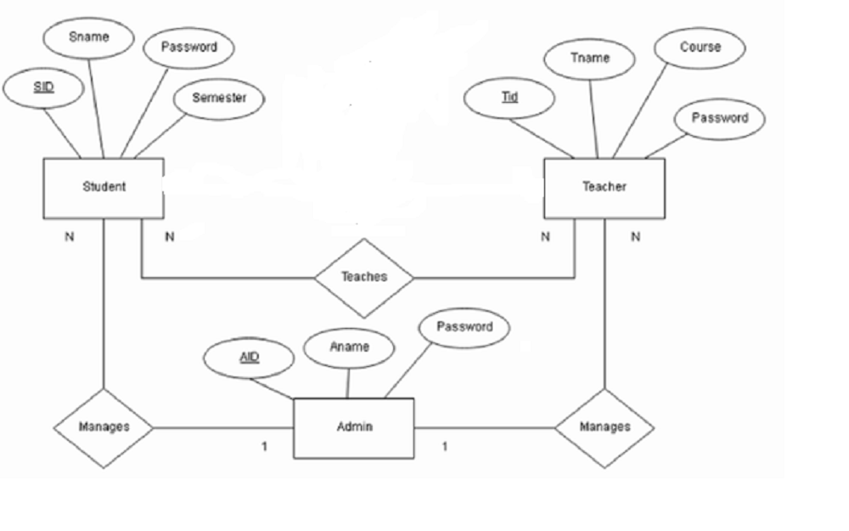

Fig. ER Diagram

**Chapter 6**

**SYSTEM ANALYSIS**

**6.1 Existing System**

System Analysis is a detailed study of the various operations performed by a system and their relationships within and outside of the system. Here the key question is- what all problems exist in the present system? What must be done to solve the problem? Analysis begins when a user or manager begins a study of the program using existing system.

During analysis, data collected on the various files, decision points and transactions handled by the present system. The commonly used tools in the system are Data Flow Diagram, interviews, etc. Training, experience and common sense are required for collection of relevant information needed to develop the system. The success of the system depends largely on how clearly the problem is defined, thoroughly investigated and properly carried out through the choice of solution. A good analysis model should provide not only the mechanisms of problem understanding but also the frame work of the solution. Thus, it should be studied thoroughly by collecting data about the system. Then the proposed system should be analyzed thoroughly in accordance with the needs.

System analysis can be categorized into four parts.

* System planning and initial investigation
* Information Gathering
* Applying analysis tools for structured analysis
* Feasibility study
* Cost/ Benefit analysis.

In the current system we need to keep a number of records related to the student and want to enter the details of the student and the marks manually. In this system only the teacher or the school authority views the mark of the student and they want to enter the details of the student. This is time consuming and has much cost.

**6.2 Proposed System**

In our proposed system we have the provision for adding the details of the students by themselves. So the overhead of the school authorities and the teachers is become less. Another advantage of the system is that it is very easy to edit the details of the student and delete a student when it found unnecessary. The marks of the student are added in the database and so students can also view the marks whenever they want.

Our proposed system has several advantages

* User friendly interface
* Fast access to database
* Less error
* More Storage Capacity
* Search facility
* Look and Feel Environment
* Quick transaction

All the manual difficulties in managing the student details in a school or college have been rectified by implementing computerization.

**6.3 Feasibility Analysis**

Whatever we think need not be feasible .It is wise to think about the feasibility of any problem we undertake. Feasibility is the study of impact, which happens in the organization by the development of a system. The impact can be either positive or negative. When the positives nominate the negatives, then the system is considered feasible. Here the feasibility study can be performed in two ways such as technical feasibility and Economical Feasibility.

**Technical Feasibility**

We can strongly says that it is technically feasible, since there will not be much difficulty in getting required resources for the development and maintaining the system as well. All the resources needed for the development of the software as well as the maintenance of the same is available in the organization here we are utilizing the resources which are available already.

**Economical Feasibility**

Development of this application is highly economically feasible .The organization needed not spend much money for the development of the system already available. The only thing is to be done is making an environment for the development with an effective supervision. If we are doing so, we can attain the maximum usability of the corresponding resources .Even after the development, the organization will not be in condition to invest more in the organization .Therefore, the system is economically feasible.

**Chapter 7**

**SYSTEM TESTING**

**7.1 Introduction**

Is the menu bar displayed in the appropriate contested some system related features included either in menus or tools? Do pull –Down menu operation and Tool-bars work properly? Are all menu function and pull down sub function properly listed ?; Is it possible to invoke each menu function using a logical assumptions that if all parts of the system are correct, the goal will be successfully achieved .? In adequate testing or non-testing will leads to errors that may appear few months later.

This create two problem

1. Time delay between the cause and appearance of the problem.

2. The effect of the system errors on files and records within the system

The purpose of the system testing is to consider all the likely variations to which it will be suggested and push the systems to limits.

The testing process focuses on the logical intervals of the software ensuring that all statements have been tested and on functional interval is conducting tests to uncover errors and ensure that defined input will produce actual results that agree with the required results. Program level testing, modules level testing integrated and carried out.

**7.2 Testing Methods**

There are two major type of testing they are

1. White Box Testing.
2. Black Box Testing.

**White Box Testing**

White box sometimes called “Glass box testing” is a test case design uses the control structure of the procedural design to drive test case.

Using white box testing methods, the following tests were made on the system

a) All independent paths within a module have been exercised once. In our system, ensuring that case was selected and executed checked all case structures. The bugs that were prevailing in some part of the code where fixed

b) All logical decisions were checked for the truth and falsity of the values.

**Black box Testing**

Black box testing focuses on the functional requirements of the software. This is black box testing enables the software engineering to derive a set of input conditions that will fully exercise all functional requirements for a program. Black box testing is not an alternative to white box testing rather it is complementary approach that is likely to uncover a different class of errors that white box methods like..

1) Interface errors

2) Performance in data structure

3) Performance errors

**Unit Testing**

Unit testing is a software verification and validation method in which a programmer tests if individual units of [source code](http://en.wikipedia.org/wiki/Source_code) are fit for use.

A unit is the smallest testable part of an application. In [procedural programming](http://en.wikipedia.org/wiki/Procedural_programming) a unit may be an individual function or procedure.

Ideally, each [test case](http://en.wikipedia.org/wiki/Test_case) is independent from the others: substitutes like [method stubs](http://en.wikipedia.org/wiki/Method_stub), objects, fakes and [test harnesses](http://en.wikipedia.org/wiki/Test_harness) can be used to assist testing a module in isolation.

**Integration Testing**

This testing is sometimes called Integration and Testing. Integration testing is the phase in software testing in which individual software modules are combined and tested as a group. It occurs after unit testing and before system testing. Integration testing takes as its input modules that have been unit tested, groups them in larger aggregates, applies tests defined in an integration test plan to those aggregates and delivers as its output the integrated system ready for system testing.

**Validation Testing**

Validation Testing can be defined in many ways, but a simple definition is that validation succeeds when the software functions in a manner that can reasonably expected by a customer. After validation test has been conducted, one of the following two possible conditions exists. The functions or performance characteristics confirm to specification and are accepted.

* In the administrator and marks modules, all the fields must be filled.
* In the student registration, mobile number should contain exactly 10 numbers.

**User Acceptance Testing**

User acceptance of a system is a key factor of any system. The system under consideration is tested for the acceptance by constantly keeping in touch with the prospective system users at the same time of developing and marketing changes whenever required. This is done in regard to the following points:

* Input Screen Design
* Output Screen Design

**Chapter 8**

**IMPLEMENTATION**

The system has a different segment to process a specific task which is the modules. This will help the system to developed easily and makes it more user-friendly.

**The modules of the project are: –**

1. Student Module
2. Faculty Module
3. Administration

**5.1 Student Module**

All student has unique username and password to access the system. After login into system student can view his profile, result and manage his account. It will be makes to the student profile database for all students. Entered Student information stored in the database course wise, department wise, semester wise and etc...

In this module, the student will get registered as it is new in the educational institute. It will be formed like a structure where all the student details will be filled. It will have the fields regarding their personal information like date of birth and address along with that it will also ask its professional details of previous education if it has. As this module is present online, the student can register them from anywhere on the internet is present. After registration information will go to the admin for authentication. This module will reduce the hectic task of taking multiple forms from the institute and filling them carefully as any mistake will lead to getting new sets of the forms.

* 1. **Faculty Module**

Faculty have unique username and password to access his system. The main aim of his system is to fulfill the student academic details and update. Faculty can add student and fill the related information. With the help of this module, we have to student registered is present. This module will really simplify the task of on paper registration. Also, after successful registration the user can update information and change their password as and when required.

* 1. **Administration**

The information of the admin of the institute is stored in this entity. It is stored data of login and the password. This provides security to the system and keeps the record of which user entered in the system at what instance of time. This entity will have the access to all the entities as it will add the student to the system. This will enter the course in the department and manage them. The admin will have the privileges to access all functions in the application.

**Chapter 9**

**TECHNOLOGY OVERVIEW**

**9.1 Front-end Technology**

Front-end web development, also known as client-side development is the practice of producing HTML, CSS and JavaScript for a website or Web Application so that a user can see and interact with them directly. The challenge associated with front end development is that the tools and techniques used to create the front end of a website change constantly and so the developer needs to constantly be aware of how the field is developing.

The objective of designing a site is to ensure that when the users open up the site, they see the information in a format that is easy to read and relevant. This is further complicated by the fact that users now use a large variety of devices with varying screen sizes and resolutions thus forcing the designer to take into consideration these aspects when designing the site. They need to ensure that their site comes up correctly in different browsers (cross-browser), different operating systems (cross-platform) and different devices (cross-device), which requires careful planning on the side of the developer.

**9.1.1 HTML**

HTML Hypertext Markup Language, commonly referred to as HTML, is the standard markup language used to create web pages. Web browsers can read HTML files and render them into visible or audible web pages. HTML describes the structure of a website semantically along with cues for presentation, making it a markup language, rather than a programming language.

**9.1.2 CSS**

Cascading Style Sheets (CSS) is a style sheet language used for describing the look and formatting of a document written in a markup language. Although most often used to change the style of web pages and user interfaces written in HTML and XHTML, the language can be applied to any kind of XML document, including plain XML, SVG and XUL. Along with HTML and JavaScript, CSS is a cornerstone technology used by most websites to create visually engaging webpages, user interfaces for web applications, and user interfaces for many mobile applications.

**9.1.3 JavaScript**

JavaScript is a high level, dynamic, untyped, and interpreted programming language. It has been standardized in the ECMAScript language specification. Alongside HTML and CSS, it is one of the three essential technologies of World Wide Web content production; the majority of websites employ it and it is supported by all modern web browsers without plug-ins. JavaScript is prototype-based with first-class functions, making it a multi-paradigm language, supporting object-oriented, imperative, and functional programming styles. It has an API for working with text, arrays, dates and regular expressions, but does not include any I/O, such as networking, storage or graphics facilities, relying for these upon the host environment in which it is embedded.

**9.2 Back-end Technology**

Backend technologies are paramount in the development of day-to-day software projects. Either you are a startup founder, IT head, or a corporate decision-maker, selecting the right backend technology is crucial to determine your project’s success.

Indeed, well-chosen backend technologies can guarantee scalability, functioning speed and instantly respond to customers’ queries and needs. Withal, it is challenging to pick the appropriate option, especially if you are a non-programmer.

**9.2.1 MySQL**

MySQL is a relational database management system (RDBMS)[1] that runs as a server providing multi-user access to a number of databases. MySQL is a popular choice of database for use in web applications and is an open-source product. The process of setting up a MySQL database varies from host to host; however, we will end up with a database name, a user name and a password. Before using our database, we must create a table. A table is a section of the database for storing related information. In a table we will set up the different fields which will be used in that table. Creating a table in phpMyAdmin is simple, we just type the name, select the number of fields and click the ‘go’ button. we will then be taken to a setup screen where you must create the fields for the database. Another way of creating databases and tables in phpMyAdmin is by executing simple SQL statements. We have used this method in order to create our database and tables.

**9.2.2 Java**

Javais one of the most powerful backend technologies, which has the second rank, according to TIOBE Index. James Gosling originally developed this programming technology in 1991, but it was published in 1995 by Sun Microsystems.

Developers prefer to make feature-rich and adaptable web applications with Java for years. Howbeit, you can use Java for mobile devices, severe, and microcontroller software development as well.

**9.2.3 Servlet**

Servlet technology is used to create a web application (resides at server side and generates a dynamic web page).

Servlet technology is robust and scalable because of java language. Before Servlet, CGI (Common Gateway Interface) scripting language was common as a server-side programming language. However, there were many disadvantages to this technology. We have discussed these disadvantages below.

There are many interfaces and classes in the Servlet API such as Servlet, GenericServlet, HttpServlet, ServletRequest, ServletResponse, etc.

**Chapter 10**

**ADVANTAGES**

**1. Improves the General Performance of Students:**

For students to come out with good grades, the focus is highly needed. With this school administration software, students are able to use their precious time for relevant things which is studying rather than keep track of their records to make sure things are intact. Moreover, fear of losing important records to manual management is completely off the line with the help of this software.

**2. Can Be Accessed by All Parties Involved:**

Gone are the days when parents know little to nothing about what their child or ward does at school. This open-source school management system has made it possible for parents to have access to their children's school activities, assignments, attendance, and other relevant information just by using the software.

**3. Helps to Keep Track of All Students:**

School activity goes beyond the wall of the classrooms. There are other activities like sports, interaction, and other extracurricular activities and all these needs proper documentation. This management software has features that see to that and make sure the record of each student is intact.

**4. Reduction of Human Labor, Papers and Workload:**

The cost incurred from employing staff to manage the activities of a school is an additional cost that shouldn't be if you decide to make use of this new technology. With this student management system, your number of staffs, excessive buying of writing materials will be minimal and functionality will improve.

**5. Helps Build a Strong Alumni:**

There is more to life than the walls of the school. This same software has the ability to build an alumni network to help other students with job referrals. All this is made possible with the help of this software.

**Chapter 11**

**CONCLUSION**

Student Management System is very useful in an institution or in college or in universities. There is no paper work in this proposed system. Supervision can be done from anywhere. This project especially minimizes human effort necessary. This application is handled by the college so there is no information leak and data will be secured. Since it is a web-based application anyone can use the system anywhere at any time and it is very easy to get the necessary information without the latency. It is very useful to the students to get their report on attendance and internal assessments. Since this application will be handled by the college whenever they need any changes in an application they can make it without the upfront investment, and the system will be more secure when it is handled by the own college.

**Chapter 12**

**FUTURE SCOPE**

The project has a very vast scope in future. The project can be implemented on intranet in future. Project can be updated in near future as and when requirement for the same arises, as it is very flexible in terms of expansion. With the proposed software of database Space Manager ready and fully functional the client is now able to manage and hence run the entire work in a much better, accurate and error free manner. The following are the future scope for the project.

➢ Discontinue of particular student eliminate potential attendance.

➢ Bar code Reader based attendance system

➢ Individual Attendance system with photo using Student login

**Chapter 13**

**REFERENCES**

[1] D. Jones and S. Behrens, Online Assignment Management: An Evolutionary Tale, paper presented at the26th Hawaii International Conference on System Sciences, Hawaii, January 2003.

[2] A.Tregobov, “The Web-Based Assignment Submission Systems”, presented at NAWeb'98, University of New Brunswick, Canada, 1998.

[3] D. Jones, B. Jamieson, “Three Generations of Online Assignment Management”, Proceedings of ASCILITE'97, R. Kevill, R. Oliver, R. Phillips, and Eds. Perth, Australia: pp317-323, 1997.

[4] Zhi-gang YUE, You-wei JIN, “The development and design of the student management system based on the network environment”, 2010 International Conference on Multimedia Communications, 978-0-7695-4136-5/10 2010 IEEE.

[5] TANG Yu-fang, ZHANG Yong-sheng, “Design and implementation of college student information management system based on the web services”. Natural Science Foundation of Shandong Province (Y2008G22), 978-1-4244-3930-0/09 2009 IEEE.

[6] Jin Mei-shan1 Qiu Chang-li 2 Li Jing 3. “The Designment of student information management system based on B/S architecture”. 978-1-4577-1415-3/12 2012 IEEE.

[7] A. Tregobov, “The Web-Based Assignment Submission Systems”, presented at NAWeb’98, University of New Brunswick, Canada, 1998.

[8] B. Collis, W. De Boer, and K. Slotman, Feedback for Web-based Assignments, Journal of Computer Assisted Learning, 17:3, pp. 306-313, 2001.

[9] D. Mason, D. Woit, “Providing mark-up and feedback to students with online marking”, Proceedings of the 30thSIGCSE Technical Symposium on Computer ScienceEducation, ACM, 2000, pp: 3-6.

[10] P. Summons, J. Coldwell, C. Bruff, F. Henskens, “Automating Assessment and Marking of Spreadsheet Concepts”, Proceedings of ACSE'97, Melbourne, Australia, 1997, pp 178-184

[11] Almahdi Alshareef, Ahmed Alkilany "Toward a Student Information System for Sebha University, Libya",Fifth international conference on Innovative Computing Technology (INTECH 2015)-p 34-39

[12] Prabhu T Kannan, Srividya K Bansal,"Unimate: A Student Information System",2013 International Conference on Advances in Computing, Communications and Informatics (ICACCI)-p-1251-1256

[13] S.R.Bharamagoudar, Geeta R.B, S.G.Totad, “Web service api for student information and course management systems”International Journal of Advanced Research in Computer and Communication Engineering Vol. June 2013

[14] Hanan A. Al-Souly, Abeer S. Al-Sheddi, Heba A. Kurdi “Enhanced TSFS Algorithm for Secure Database Encryption” Science and Information Conference 2013. -p328-335